Ex.no:9 | MINI PROJECT - FINANCIAL DATA ANALYTICS
Date: | MINI PROJECT - FINANCIAL DATA ANALYTICS

Domain and Problem Statement
Domain: Finance – Retail Lending and Credit Risk Analytics
Retail lending institutions approve large volumes of unsecured and secured loans on the basis of borrower attributes captured at the point of application. Once disbursed, a proportion of these loans default, and the resulting write-offs represent the single largest controllable loss on a consumer lending book. The difficulty for a lender is not that defaults occur, but that the attributes driving them are distributed across many weakly correlated fields – age, income, employment status, credit score, loan size, interest rate and existing obligations – none of which is individually decisive. A portfolio-level default rate reported as a single figure therefore conceals segments performing several times worse than the average, and lending policy calibrated to that average will systematically under-price risk in exactly those segments.
This project addresses that problem by constructing an end-to-end analytical pipeline over a retail loan portfolio of 255,347 records. The raw application data is validated and enriched in Python, persisted to a relational store in Microsoft SQL Server, and modelled in Power BI and Tableau to quantify how default risk varies across borrower and loan characteristics. The objective is to identify which attributes genuinely separate defaulting from repaying borrowers, to measure the magnitude of that separation rather than merely its direction, and to isolate the specific borrower segments in which credit loss is concentrated so that underwriting thresholds can be targeted at them.
Dataset Description
Dataset Name: Loan Default Prediction Dataset (Loan_default.csv)
Granularity: One row per disbursed loan, uniquely identified by LoanID. The dataset contains 255,347 loan records described by 18 source attributes, extended to 28 attributes after feature engineering. Each record represents a completed lending decision together with its eventual repayment outcome.
Key Entities and Attributes:
• Loan Identity – LoanID uniquely identifies each disbursed loan and serves as the primary key of the fact table.
• Borrower Demographics – Age, Income, Education, EmploymentType, MaritalStatus, HasDependents and MonthsEmployed describe the applicant at the time of application.
• Credit Profile – CreditScore, NumCreditLines, DTIRatio, HasMortgage and HasCoSigner capture the applicant's existing credit standing and obligations.
• Loan Characteristics – LoanAmount, InterestRate, LoanTerm and LoanPurpose describe the terms on which credit was extended.
• Outcome – DefaultFlag is a binary indicator recording whether the loan ultimately defaulted, and is the target attribute of the analysis.
• Engineered Attributes – AgeGroup, IncomeBand, CreditBand, DTIBand, RateBand, LTIBand, LoanToIncome, MonthlyPayment, PaymentToIncomePct and DefaultStatus are derived in Python to support banded aggregation and ratio analysis.
Data Source
Primary Source: The dataset is sourced from Kaggle, published as the Loan Default Prediction Dataset. It is distributed as a single comma-separated file of approximately 24 MB containing 255,347 complete loan records with no missing values and no duplicate identifiers.
Storage Infrastructure: The cleaned and enriched dataset is persisted in Microsoft SQL Server 2025 in a database named financeDB, within a single table dbo.loans of 28 explicitly typed columns. The database engine runs as the default instance MSSQLSERVER and is accessed over Windows Authentication. Both Power BI Desktop and Tableau Desktop connect directly to this table, ensuring that every figure reported by either tool resolves to the same persisted source rather than to independently held copies of the file.
Architecture:
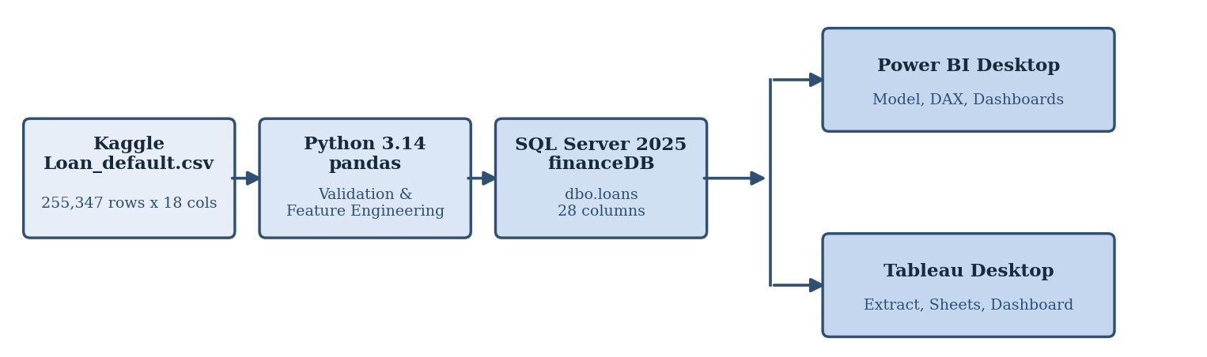
The pipeline is linear up to the point of storage and then fans out to two independent presentation tools. The raw Kaggle extract is read into Python, where it is validated and enriched, and written back as a cleaned flat file. That file is imported into SQL Server under an explicitly declared schema, which becomes the single authoritative source. Power BI connects in Import mode to build a dimensional model with calculated columns and DAX measures, while Tableau connects to the same table through a materialised extract. Because both tools read from one persisted table, the aggregate figures they produce are directly comparable and can be cross-validated against the original Python output.
Program:
The following Python program performs validation and feature engineering on the raw dataset. Since the source file contains no null values and no duplicate records, the cleaning stage operates as a verification step, and the substantive transformation is the derivation of ten additional attributes used throughout the downstream analysis.
import pandas as pd
import numpy as np

IN_PATH = r"C:\miniproject\Loan_default.csv"
OUT_PATH = r"C:\miniproject\loan_cleaned.csv"

# ---------- STAGE 1 : DATA VALIDATION ----------
df = pd.read_csv(IN_PATH)
print("Original Shape :", df.shape)
print("Null values per column :", df.isnull().sum().sum())
print("Duplicate rows :", df.duplicated().sum())
df = df.drop_duplicates()
print("Duplicate LoanIDs :", df["LoanID"].duplicated().sum())

df.columns = df.columns.str.strip()
text_cols = [c for c in df.columns if pd.api.types.is_string_dtype(df[c])]
for c in text_cols:
df[c] = df[c].str.strip()
print(df.dtypes.to_string())

# ---------- STAGE 2 : FEATURE ENGINEERING ----------
df["AgeGroup"] = pd.cut(df["Age"], bins=[17, 25, 35, 45, 55, 100],
labels=["18-25", "26-35", "36-45", "46-55", "56+"]).astype(str)

df["IncomeBand"] = pd.cut(df["Income"], bins=[0, 40000, 70000, 100000, 999999],
labels=["Low (<40K)", "Lower-Mid (40-70K)",
"Upper-Mid (70-100K)", "High (100K+)"]).astype(str)

df["CreditBand"] = pd.cut(df["CreditScore"], bins=[299, 450, 600, 700, 850],
labels=["Poor", "Fair", "Good", "Excellent"]).astype(str)

df["DTIBand"] = pd.cut(df["DTIRatio"], bins=[0, 0.3, 0.5, 0.7, 1.0],
labels=["Low", "Moderate", "High", "Very High"]).astype(str)

df["RateBand"] = pd.cut(df["InterestRate"], bins=[0, 8, 14, 20, 100],
labels=["<8%", "8-14%", "14-20%", "20%+"]).astype(str)

df["LoanToIncome"] = (df["LoanAmount"] / df["Income"]).round(3)
df["LTIBand"] = pd.cut(df["LoanToIncome"], bins=[-0.01, 1, 2, 3, 999],
labels=["<1x", "1-2x", "2-3x", "3x+"]).astype(str)

r = df["InterestRate"] / 100 / 12
n = df["LoanTerm"]
df["MonthlyPayment"] = (df["LoanAmount"] * r / (1 - (1 + r) ** (-n))).round(2)
df["PaymentToIncomePct"] = (df["MonthlyPayment"] /
(df["Income"] / 12) * 100).round(2)
df["DefaultStatus"] = np.where(df["Default"] == 1, "Defaulted", "Repaid")

# ---------- STAGE 3 : SUMMARY ----------
print("Cleaned Shape :", df.shape)
print("Total loan value : {:,.0f}".format(df["LoanAmount"].sum()))
print("Average loan amount : {:,.2f}".format(df["LoanAmount"].mean()))
print("Average interest rate : {:.2f}%".format(df["InterestRate"].mean()))
print("Overall default rate : {:.2f}%".format(df["Default"].mean() * 100))
print((df.groupby("AgeGroup")["Default"].mean() * 100).round(2).to_string())

df.to_csv(OUT_PATH, index=False)
print("Cleaned file exported to :", OUT_PATH)

Output of the Python program:
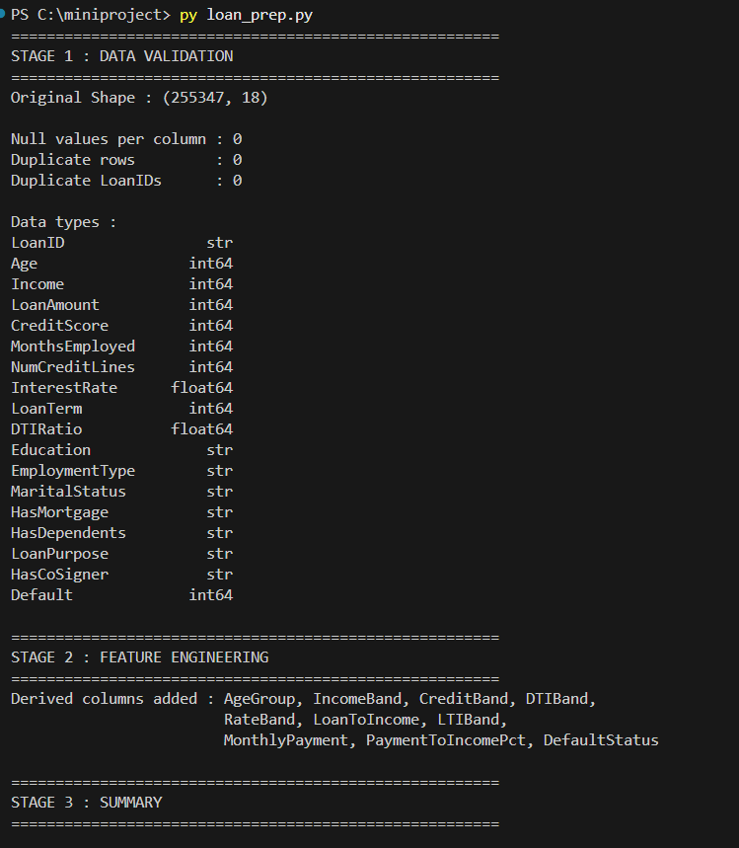
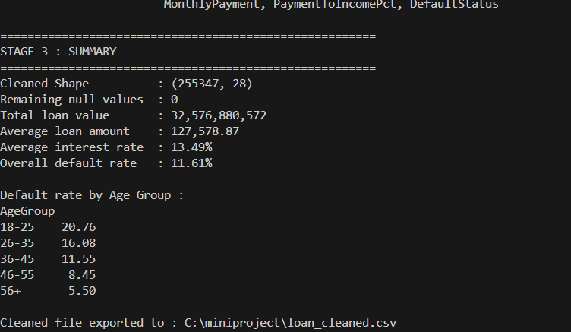
The program confirms that the source file contains 255,347 records across 18 columns with zero nulls and zero duplicates, and that the enriched dataset retains all 255,347 records across 28 columns. The portfolio carries a total disbursed value of 32,576,880,572 at an average loan size of 127,578.87 and an average interest rate of 13.49 per cent, against an overall default rate of 11.61 per cent.
SQL Server Connectivity:
1) The SQL Server database engine is accessed through SQL Server Management Studio. The connection is established to the default instance using Windows Authentication, with the Trust server certificate option enabled so that the encrypted local connection is accepted without a certificate authority.
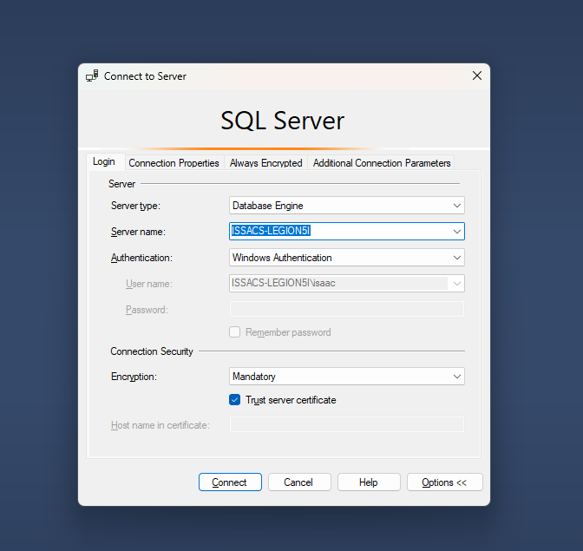
2) A new database named financeDB is created to hold the project data. The CREATE DATABASE statement executes successfully and the database appears in the Object Explorer tree alongside the existing databases on the instance.
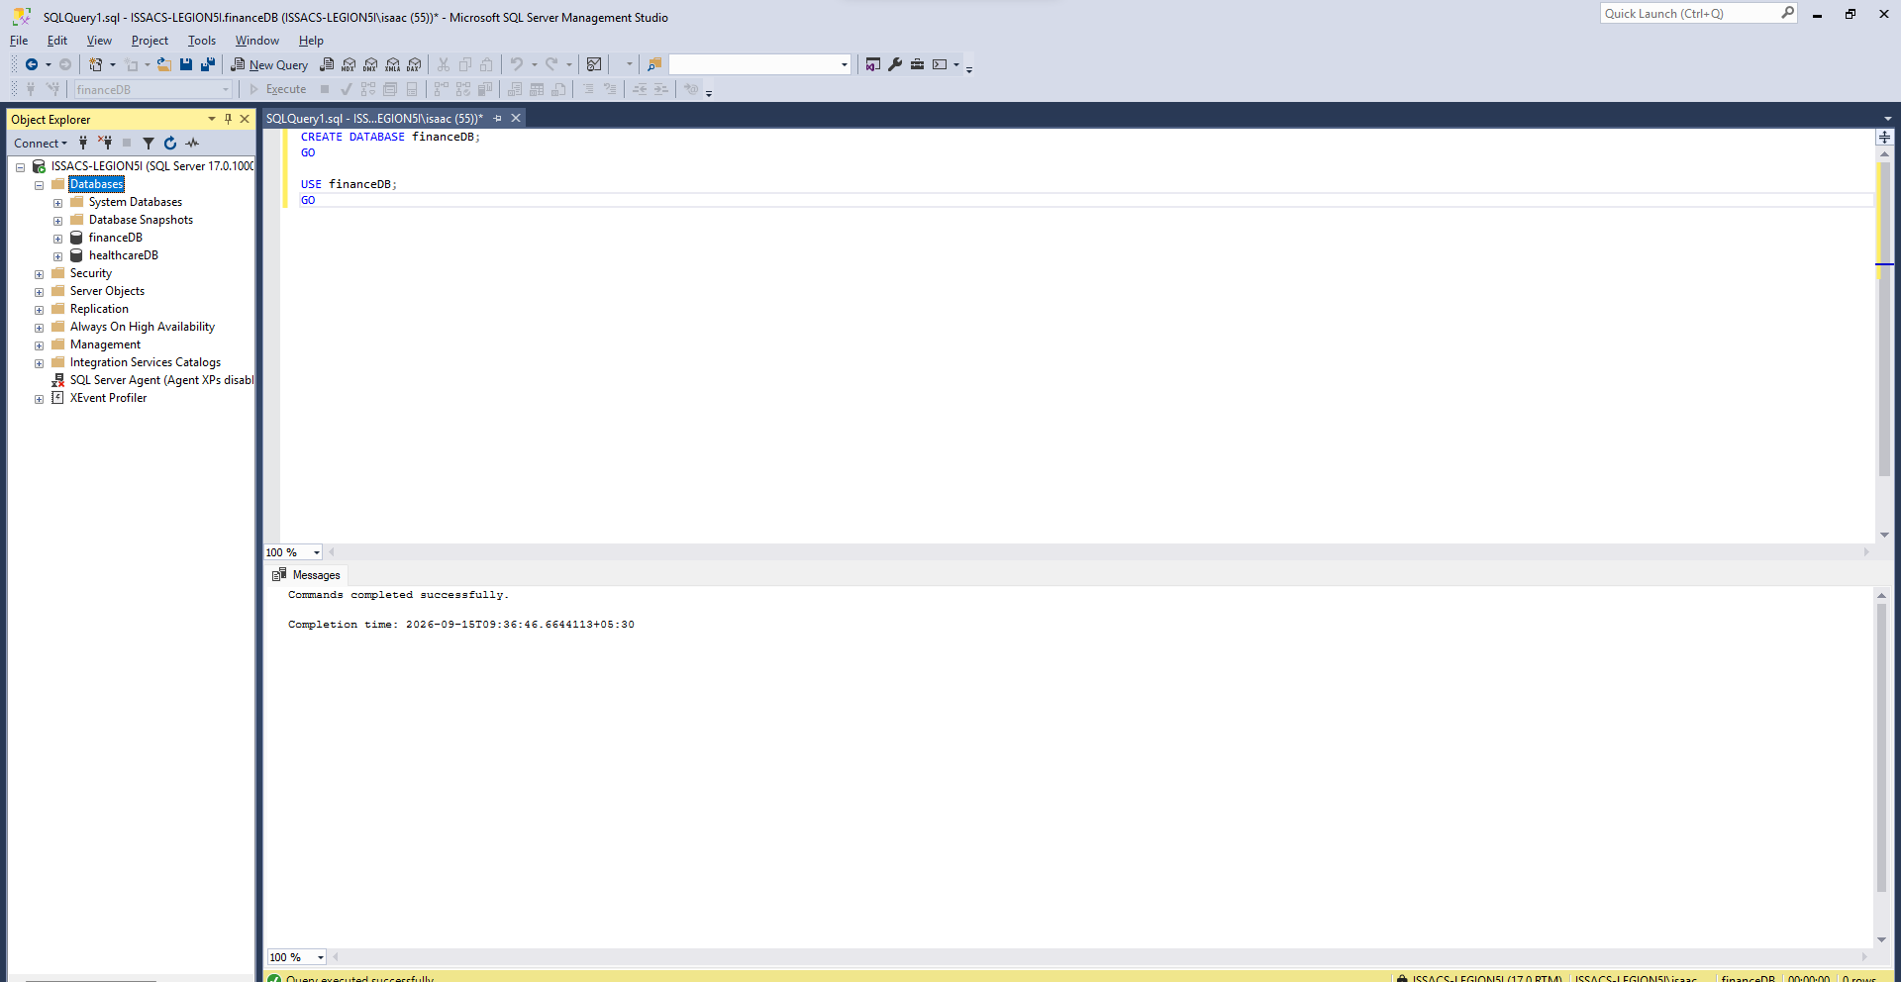
3) The cleaned file is loaded using the Import Flat File wizard. The schema inferred by the wizard is corrected before import: the columns HasMortgage, HasDependents and HasCoSigner are inferred as bit but hold the text values Yes and No, and are therefore redefined as varchar. The outcome column Default is a reserved keyword in Transact-SQL and is renamed to DefaultFlag with an integer type, so that it can be aggregated by SUM in downstream measures.
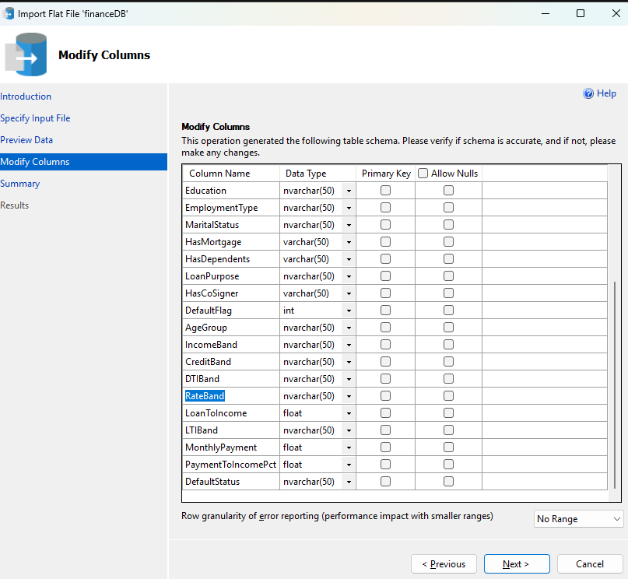
4) The import operation completes successfully, writing all 255,347 records into the table dbo.loans.
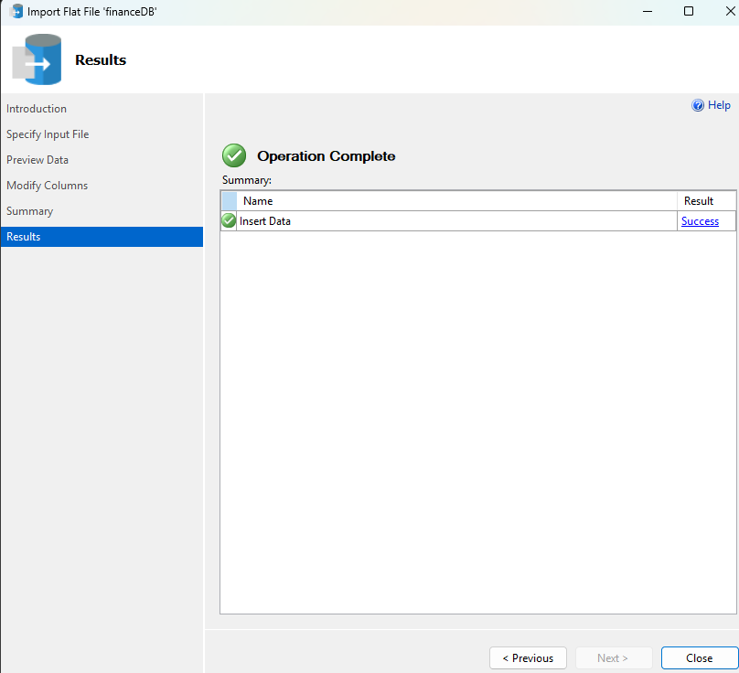
5) The imported data is verified against the Python output by re-computing the headline aggregates directly in SQL. The query returns 255,347 rows, a total loan value of 32,576,880,572, an average loan amount of 127,578.87, an average interest rate of 13.49 per cent and an overall default rate of 11.61 per cent. The default rate by age group reproduces the Python figures exactly, confirming that no records or precision were lost in transit.
SELECT COUNT(*) AS TotalLoans,
SUM(CAST(LoanAmount AS BIGINT)) AS TotalLoanValue,
CAST(AVG(CAST(LoanAmount AS FLOAT)) AS DECIMAL(12,2)) AS AvgLoanAmount,
CAST(AVG(InterestRate) AS DECIMAL(5,2)) AS AvgInterestRate,
CAST(AVG(CAST(DefaultFlag AS FLOAT)) * 100 AS DECIMAL(5,2)) AS DefaultRatePct
FROM dbo.loans;

SELECT AgeGroup, COUNT(*) AS Loans,
CAST(AVG(CAST(DefaultFlag AS FLOAT)) * 100 AS DECIMAL(5,2)) AS DefaultRatePct
FROM dbo.loans
GROUP BY AgeGroup
ORDER BY AgeGroup;
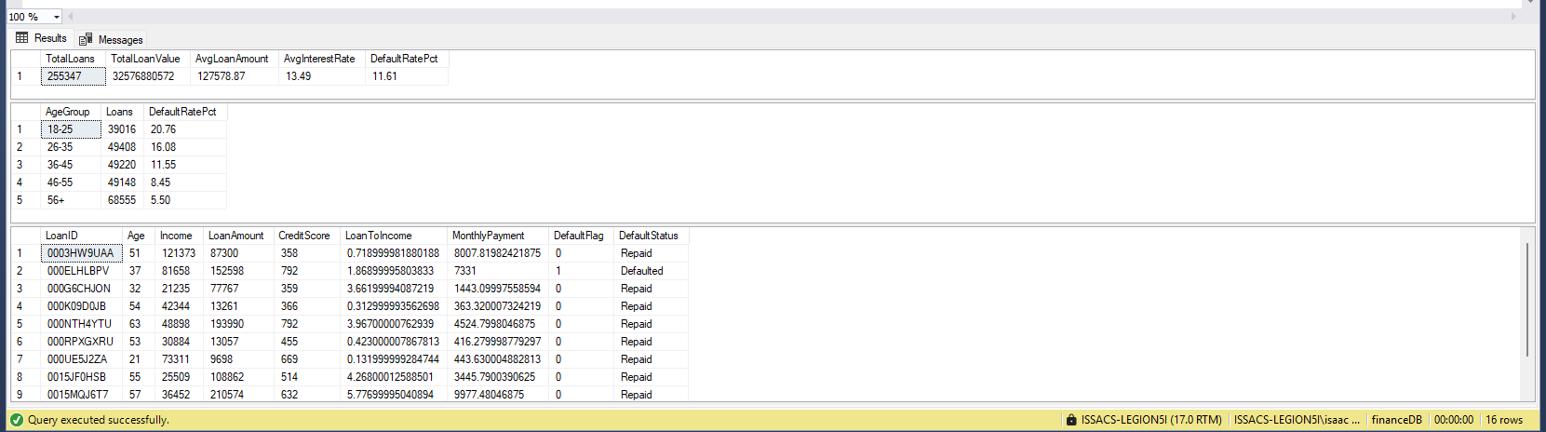
Power BI:
6) Power BI Desktop connects to the financeDB database in Import mode. The Navigator window lists the loans table, and the preview confirms that the records match those held in SQL Server.
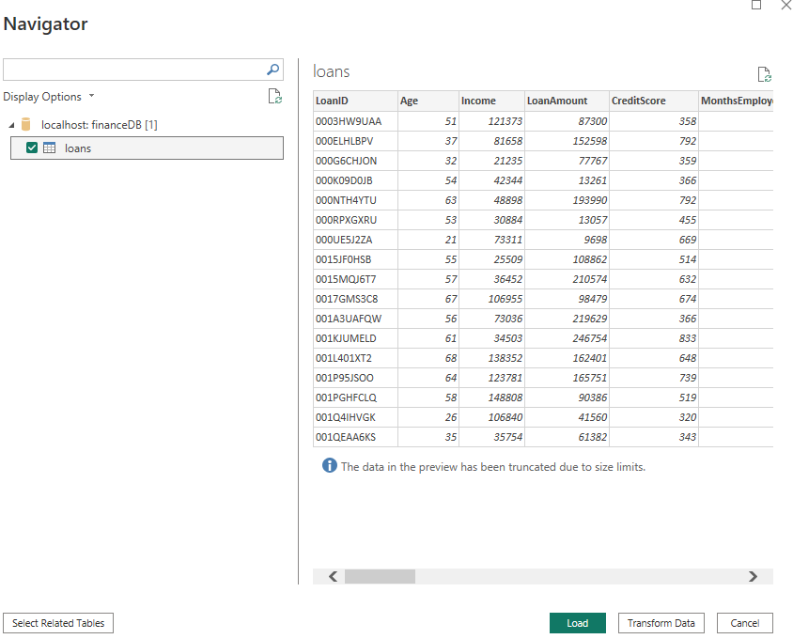
7) The three derived ratio columns are rounded to two decimal places in the Power Query Editor. Floating point storage renders LoanToIncome and MonthlyPayment with excessive precision, and the Number.Round transformation normalises them before the model is loaded.
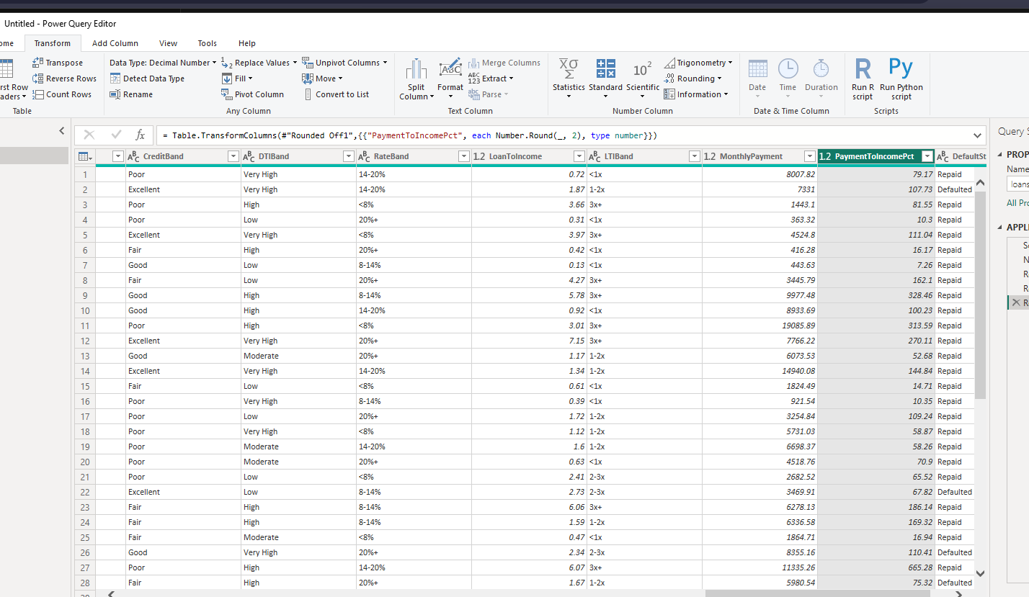
8) A dimension table named DimLoanPurpose is created using the DATATABLE function. It classifies the five loan purposes into secured and unsecured categories, which converts the single flat table into a star schema and provides the upper level of a drill-down hierarchy.
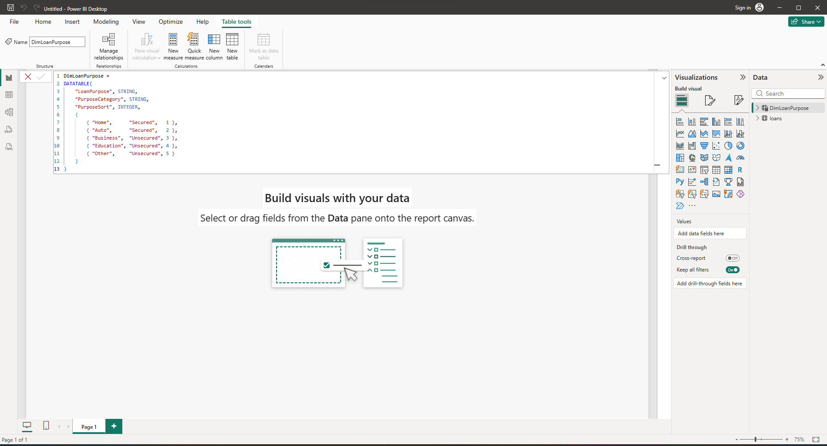
9) A many-to-one relationship is established from loans[LoanPurpose] to DimLoanPurpose[LoanPurpose], with a single cross-filter direction. The dimension table therefore filters the fact table in the expected direction while leaving the fact table unable to filter the dimension.
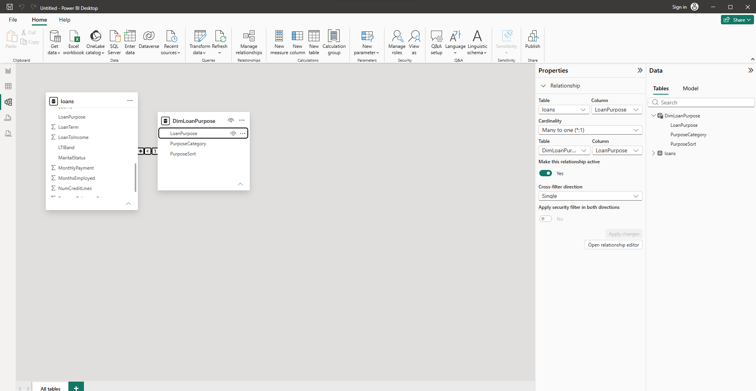
10) A two-level hierarchy is defined on the dimension table, from PurposeCategory down to LoanPurpose, enabling drill-down within any visual that uses it as a category field. Six sort-order columns are also added to the fact table, because the banded attributes would otherwise sort alphabetically and present risk categories out of sequence.
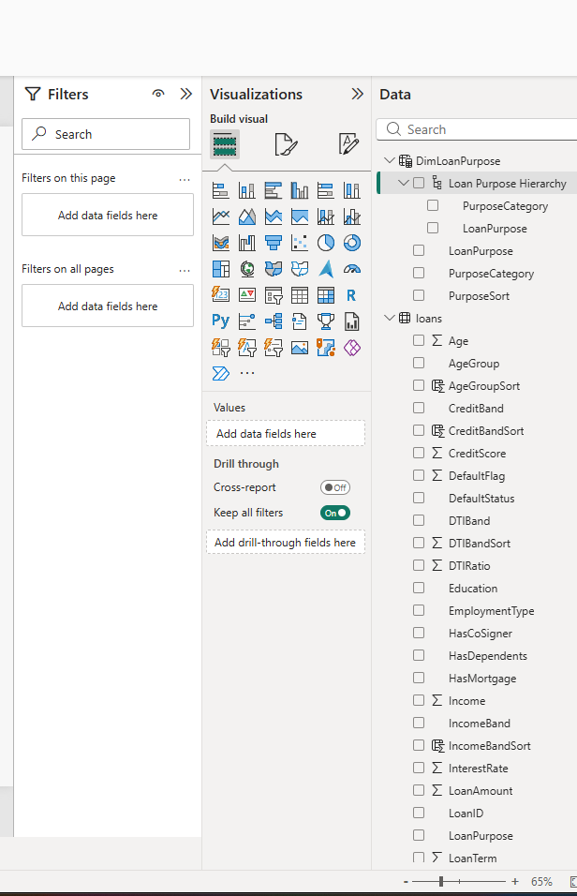
11) Ten DAX measures are defined over the model: Total Loans, Total Loan Value, Avg Loan Amount, Total Defaults, Default Rate %, Avg Interest Rate, Value at Risk, Avg Credit Score, Default Rate vs Portfolio and High Risk Loans. The measure shown below computes the difference between the default rate of the current filter context and the unfiltered portfolio rate, allowing any segment to be expressed as a variance against the 11.61 per cent baseline.
Default Rate % = DIVIDE([Total Defaults], [Total Loans], 0)

Value at Risk = CALCULATE(SUM(loans[LoanAmount]), loans[DefaultFlag] = 1)

Default Rate vs Portfolio =
VAR SegmentRate = [Default Rate %]
VAR PortfolioRate = CALCULATE([Default Rate %], REMOVEFILTERS())
RETURN SegmentRate - PortfolioRate

High Risk Loans =
CALCULATE(
COUNTROWS(loans),
loans[LTIBand] = "3x+",
loans[CreditBand] = "Poor"
)
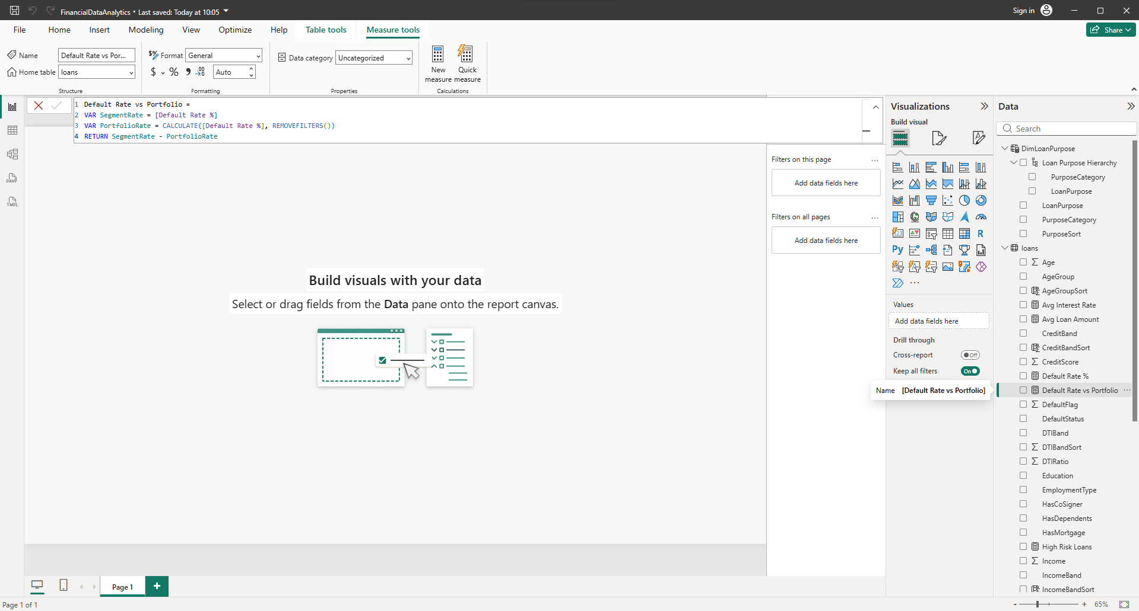
12) The Default Rate % measure is validated against a card visual, which returns 11.61 per cent and confirms that the DAX definition agrees with both the Python computation and the SQL verification query.
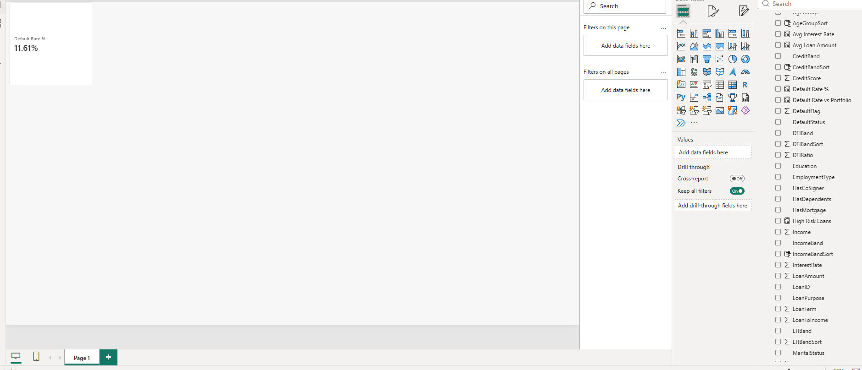
13) The Portfolio Overview page presents the portfolio at rest. Five cards report the headline measures, a column chart shows default rate by age group, a bar chart shows disbursed value by purpose category using the hierarchy, and a donut chart shows the composition of the book by credit band. Three slicers filter the page by employment type, income band and loan purpose.
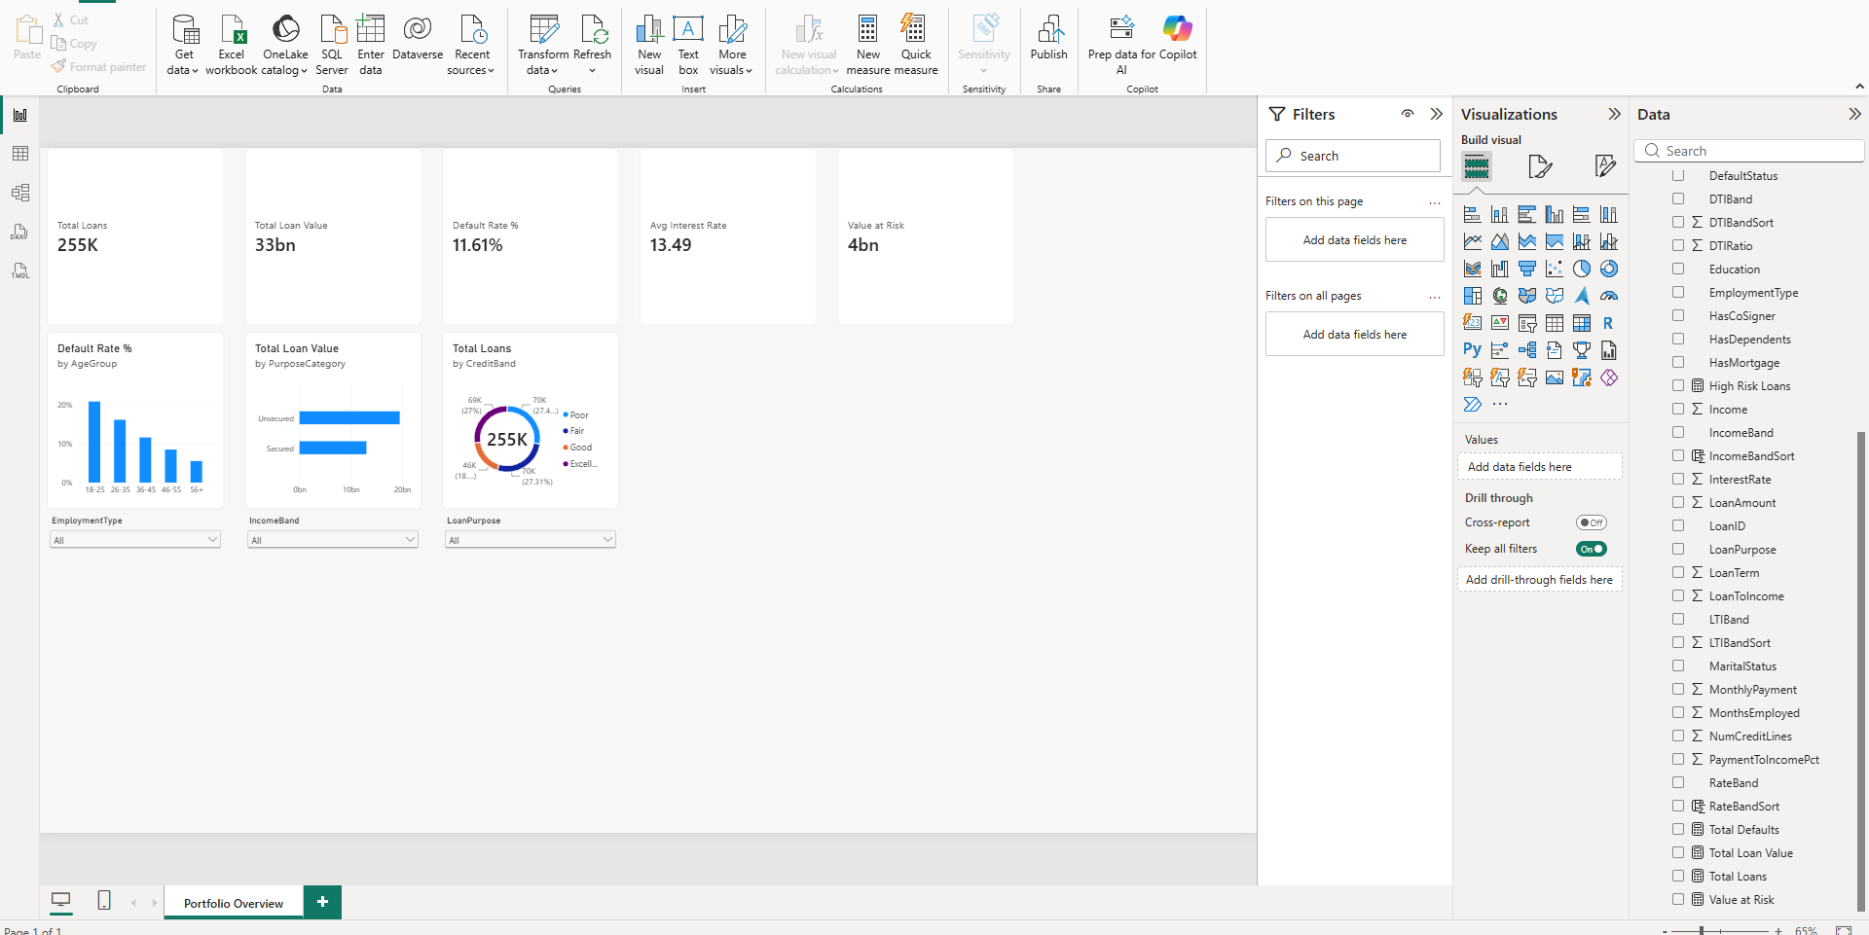
14) Applying the employment type slicer demonstrates that the page responds as a single filtered unit. Restricting the view to unemployed borrowers reduces the book from 255,347 loans to approximately 64,000 and raises the default rate from 11.61 per cent to 13.55 per cent.
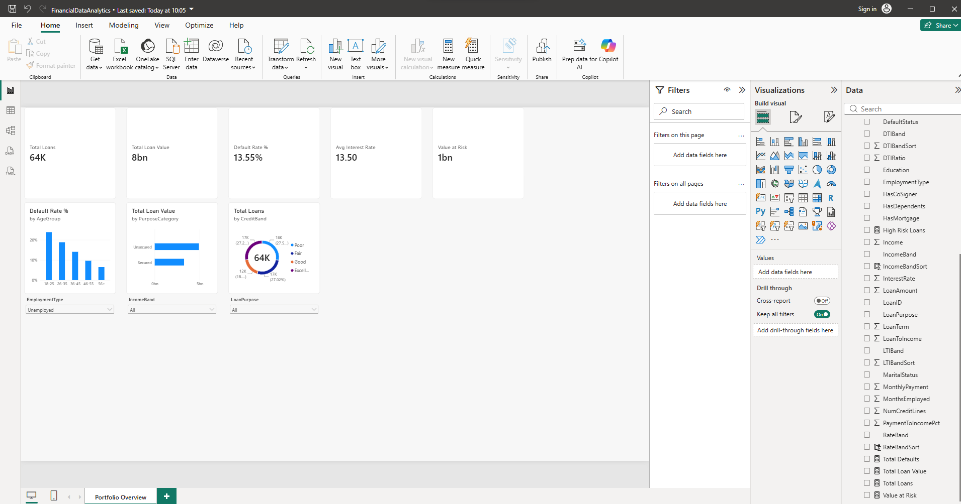
15) The Risk Analysis page applies the analytical visuals. The key influencers visual ranks the attributes that most increase the likelihood of default, the decomposition tree drills progressively into the worst-performing segment, the variance chart expresses each employment type as a deviation from the portfolio baseline, and the matrix presents credit band against loan-to-income band with conditional formatting applied to the default rate.
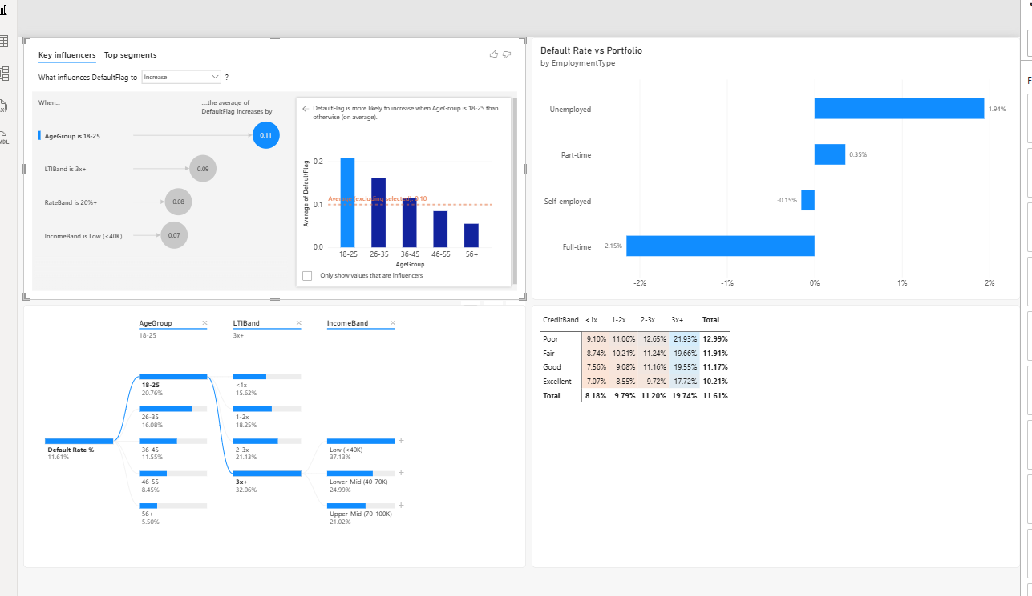
16) Drill-through is configured on the age group attribute, allowing any age-group data point on the overview page to be expanded into a record-level detail page through the right-click context menu.
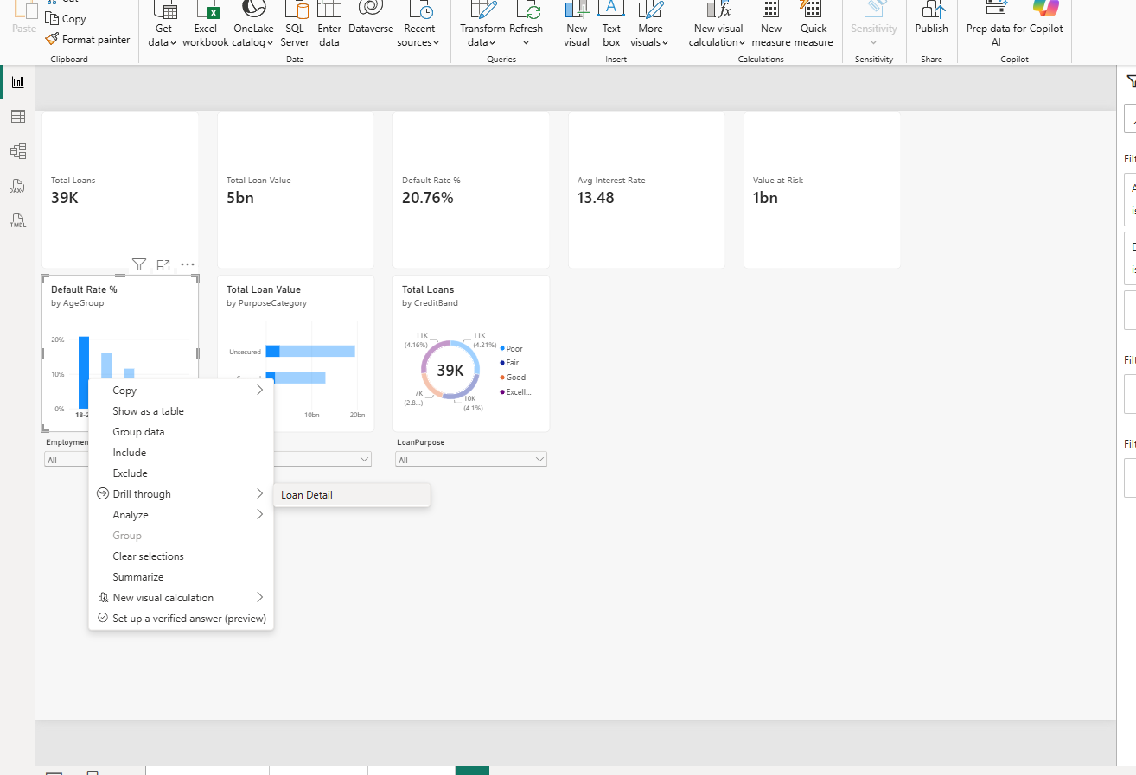
17) The Loan Detail page opens filtered to the selected age group. For the 18-25 cohort it reports approximately 39,000 loans at a default rate of 20.76 per cent, together with a row-level table of the underlying loan records and a breakdown of default rate by credit band within that cohort.
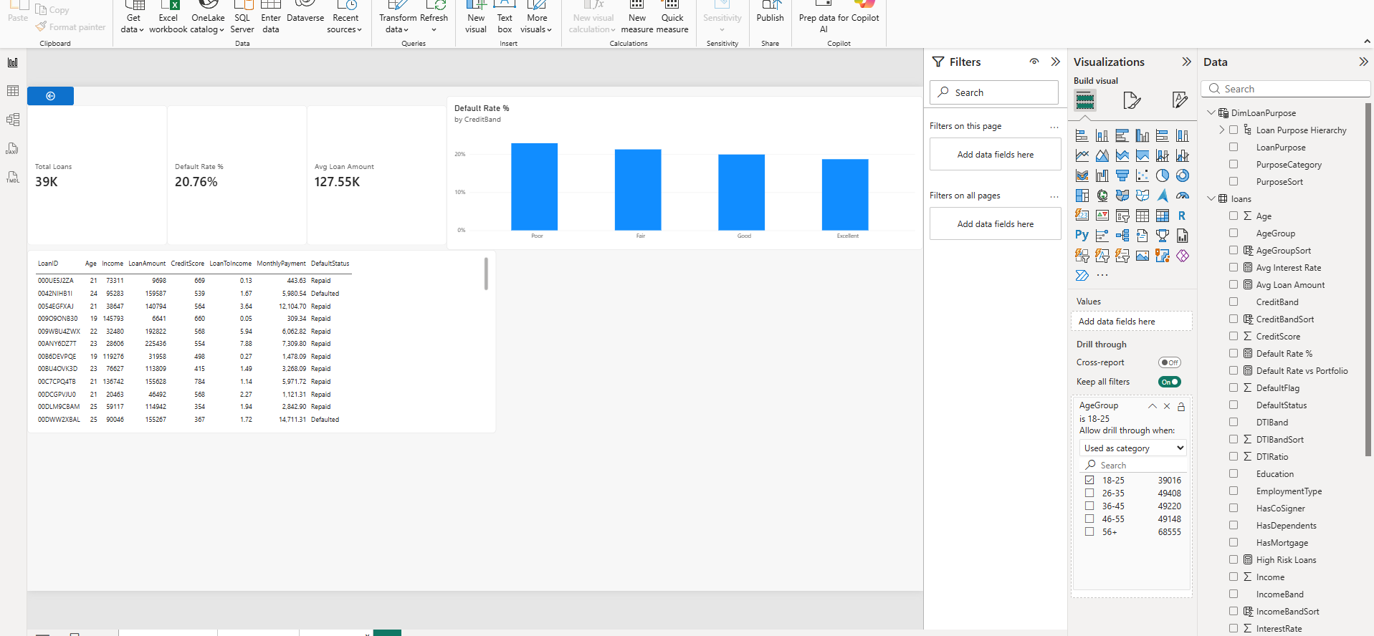
Tableau:
18) Tableau Desktop connects to the same financeDB database and materialises the loans table as an extract. The data source page confirms 28 fields and 255,347 rows.
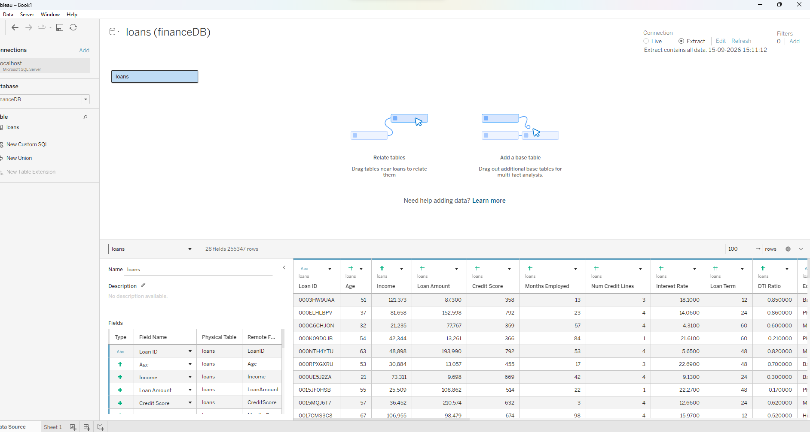
19) To visualise how default risk varies with borrower age, a calculated field Default Rate is defined as AVG([Default Flag]) and formatted as a percentage, and plotted against age group.
Default Rate = AVG([Default Flag])
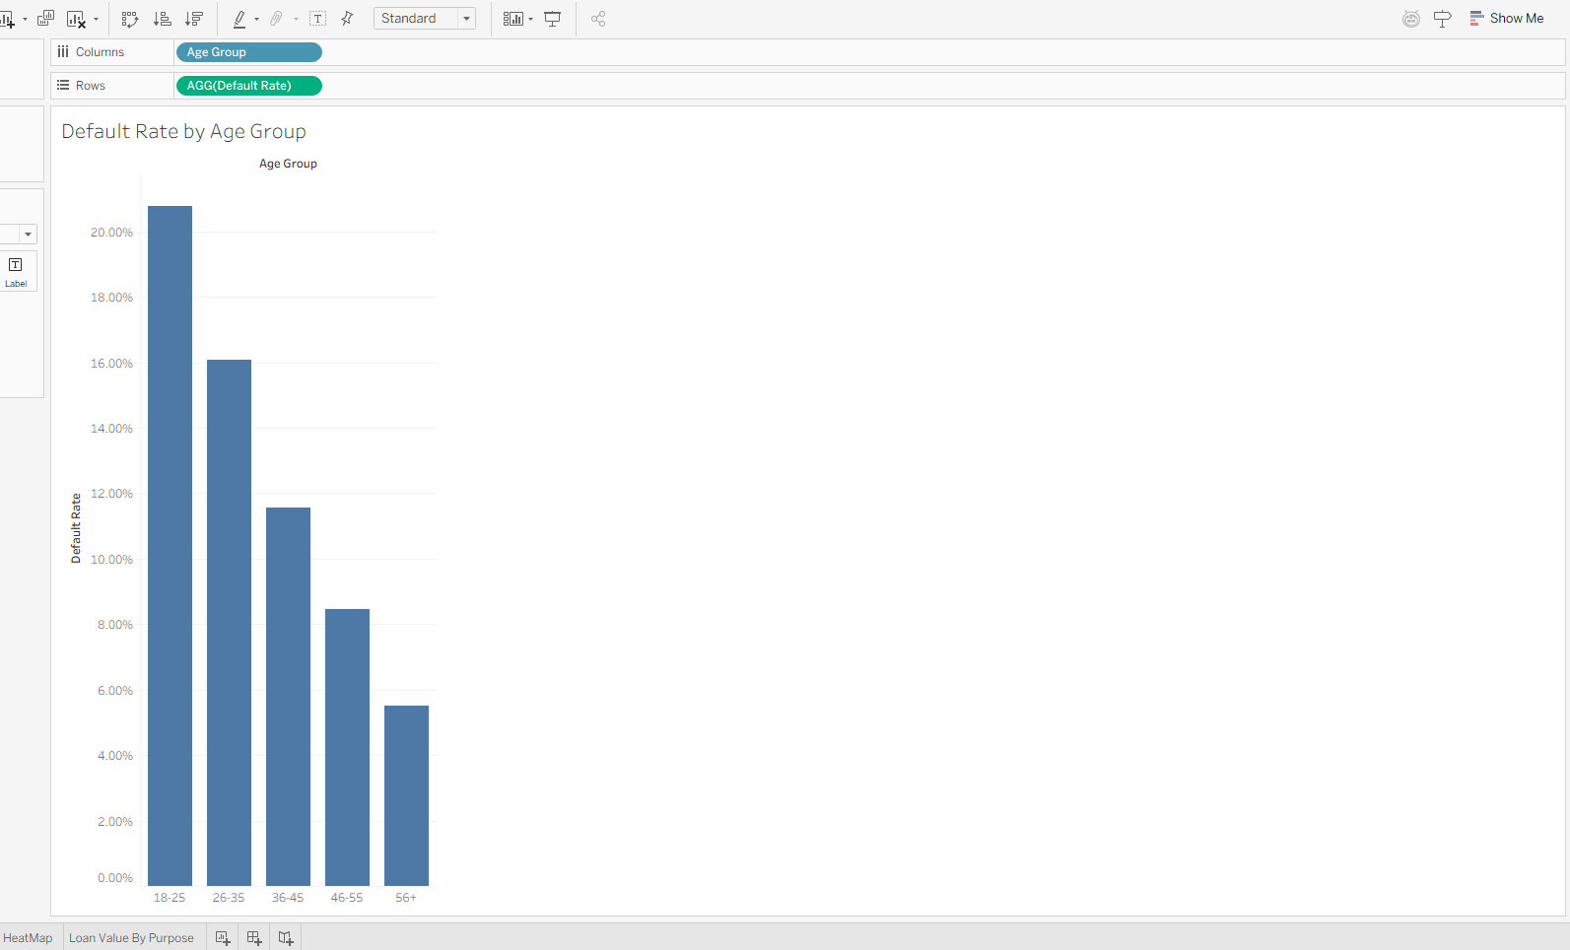
20) To visualise the interaction between credit standing and borrowing leverage, a heat map is built with credit band on rows and loan-to-income band on columns, with the default rate encoded on both colour and label.
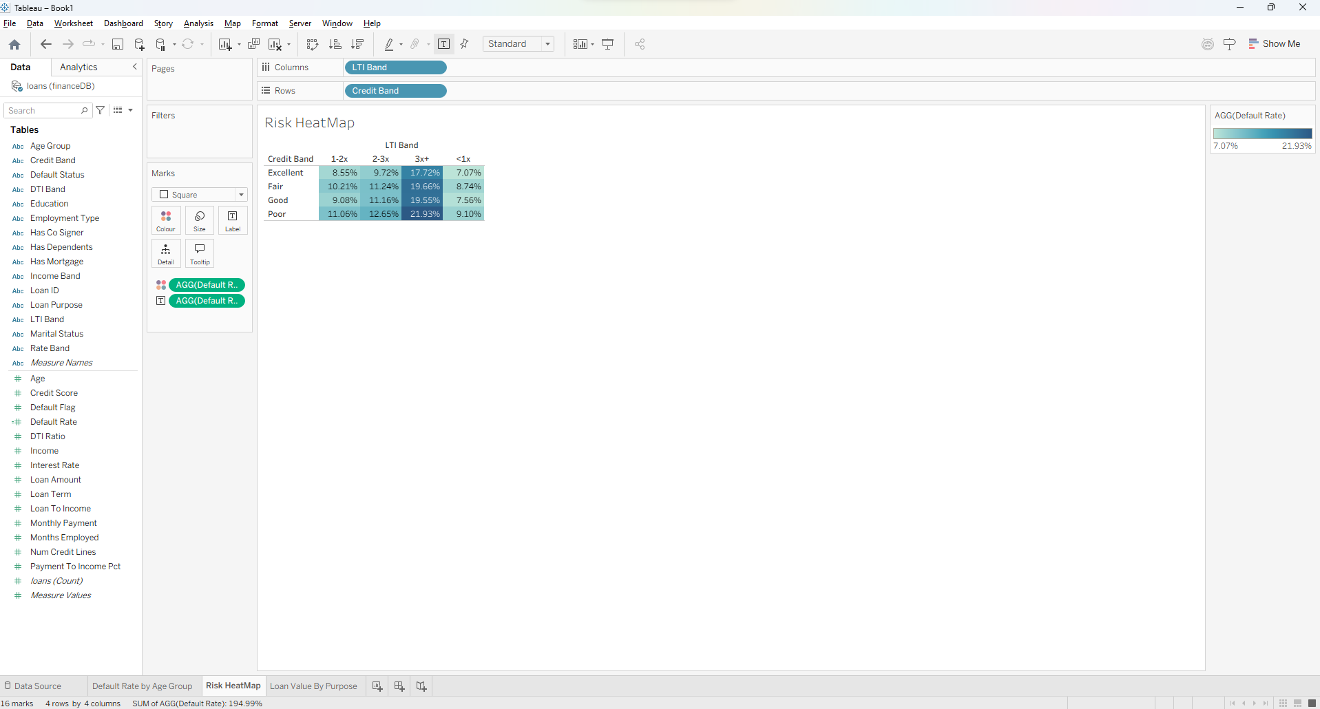
21) To visualise how lending volume and risk are distributed across loan purposes, disbursed value is plotted by purpose with the default rate encoded on colour.
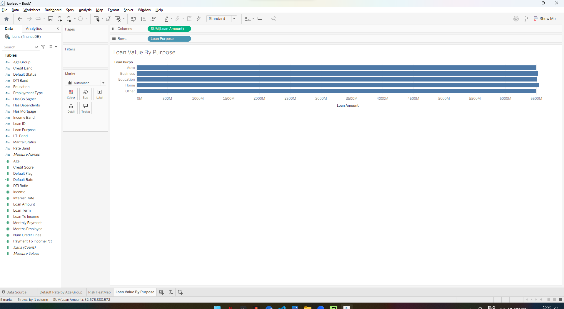
22) The three worksheets are combined into a dashboard with an employment type filter applied across all views, so that a single selection propagates to every visual on the dashboard.
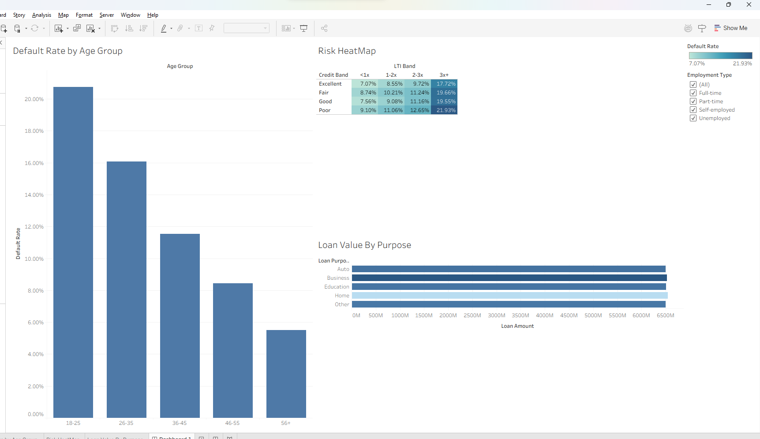
23) Filtering the dashboard to unemployed borrowers demonstrates the linked behaviour. The worst cell of the heat map rises from 21.93 per cent to 24.62 per cent, the age profile steepens, and the disbursed value scale contracts accordingly.
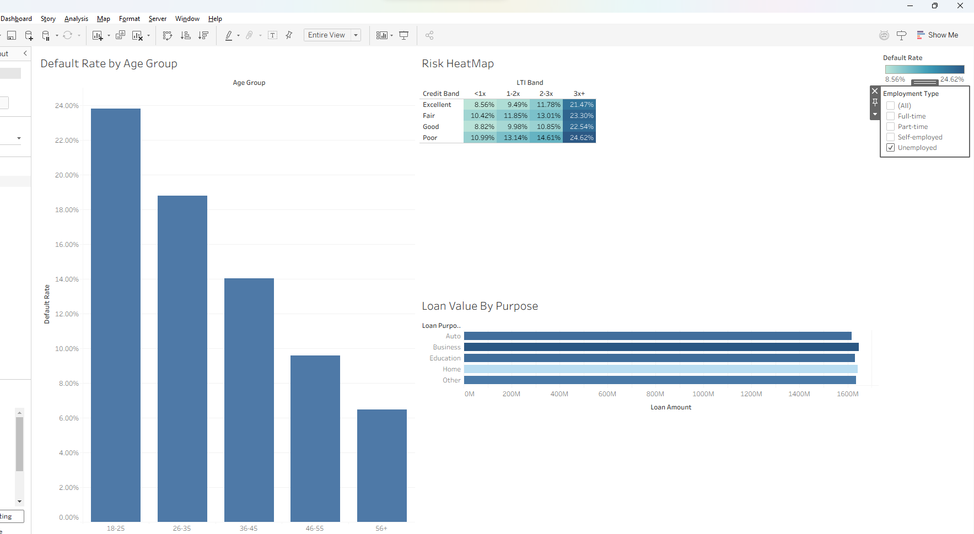

Observed Insights
1) Default risk is concentrated in young, highly leveraged, low-income borrowers.
The portfolio defaults at 11.61 per cent overall, but the decomposition tree shows that borrowers aged 18 to 25 default at 20.76 per cent, that those among them borrowing more than three times their income default at 32.06 per cent, and that the low-income subset of that group defaults at 37.13 per cent. This final segment therefore fails at more than three times the portfolio rate. Because the three attributes compound rather than merely coexist, underwriting thresholds applied to any one of them in isolation will continue to admit the segment that drives the majority of credit loss.
2) Loan-to-income ratio is a stronger predictor of default than credit score.
The risk matrix shows that moving from a loan-to-income ratio below one to a ratio above three raises the default rate from 8.18 per cent to 19.74 per cent, whereas moving from an excellent credit score to a poor one raises it only from 10.21 per cent to 12.99 per cent. The leverage effect is thus close to four times larger than the credit score effect across the same portfolio. This is notable because loan-to-income is a derived attribute computed during feature engineering, while credit score was supplied in the source data as the intended measure of creditworthiness.
3) Employment status shifts default risk by nearly four percentage points.
Expressed as a variance against the portfolio baseline, unemployed borrowers default 1.94 percentage points above the portfolio rate while full-time borrowers default 2.15 percentage points below it, a spread of 4.09 percentage points between the two extremes. Part-time and self-employed borrowers sit close to the baseline at plus 0.35 and minus 0.15 percentage points respectively. Employment status is therefore a meaningful discriminator only at its extremes, and treating it as a four-level categorical risk factor overstates the information carried by its middle categories.
4) Loan term has no measurable relationship with default behaviour.
Default rates across the available loan terms of 12, 24, 36, 48 and 60 months vary only between 11.57 per cent and 11.70 per cent, a spread of 0.13 percentage points against a portfolio rate of 11.61 per cent. This range is negligible relative to the variation observed across age, income and leverage, and is consistent with no relationship at all. The finding is useful in the negative: loan term can be excluded from risk-based pricing on this portfolio, allowing it to be set according to borrower affordability rather than being treated as a risk factor in its own right.

